Managing Records as Reliable Evidence for ICT/ e-Government and Freedom of Information

Burundi Court Case Study



International Records Management Trust

August 2011

Contents

 | Page
Introduction | 2
The Court in the Judicial Structure | 2
ICT in the Judiciary | 2
Records Management in the Judiciary | 3
Records Management Integration with Case Management Systems | 7
Conclusion | 7

Introduction

The purpose of the court case studies is to examine the manner in which the courts are handling records management in the electronic environment. In particular, the studies assess case management systems, where they are in use, to determine the extent to which international good practice in records management is being considered. This case study was conducted at the Supreme Court of Burundi.

The Court in Judicial Structure

The Ministry of Justice and the Lord Chancellor's Office oversees the operations of the Supreme Court of Burundi. The Ministry is responsible for allotting the Court its budget and overseeing its expenditure.

The Supreme Court is comprised of a judicial chamber, an administrative chamber and a High Court of Appeal. The judicial chamber is composed of two sections: the first degree section and the appeals section. The Supreme Court is staffed by a president, vice president, 15 magistrates/ counsellors, seven clerks, five assistant clerks and one junior court officer. The vice-president is the ex-officio president of the High Court of Appeal.

The Supreme Court, when convened as the High Court of Appeal, has the power to rescind or overturn judgments and decrees or any other decision by lesser courts. Collectively the chambers of the court are responsible for issuing final and binding rulings on cases where the matter has proceeded to appeal but the original appeal ruling has been overturned.

The administration of the Supreme Court is overseen by the President of the Court. The magistrates of the court form the Court General Assembly, which deliberates on all matters or issues related to the proper functioning of the judicial services.

The court clerks are appointed through ministerial ordinance issued by the Ministry of Justice and the Lord Chancellor's Office. They are overseen and guided by the chief registrar and their responsibilities include registration and the daily management of active administrative files and court case files.

ICT in the Judiciary

Burundi has defined its national ICT strategies in its Vision 2025 strategy and in the 2010-2025 ICT Strategic Implementation Plan. However, there are few operational ICT projects in Government. ICT in the Judiciary is limited to website capacity studies and website design. Conscious of the problems surrounding communication within the Judiciary and in Government, the Supreme Court of Burundi has purchased computers with donor funds. Furthermore, in preparation for the automation of court processes, the Supreme Court intends to provide court clerks with hands-on computer training.

In 2009, the Justice & Démocratie Branch of the Belgian NGO Re’seau d Citoyens (Citizens Network) initiated a project to automate the processes of the Supreme Court by supplying computers and internet connectivity to key offices. The European Union, under the auspices of the GATWARANEZA project, is presently studying the progress of the Justice & Démocratie project to understand how to better support the automation of court functions and effective information management. The current study is still in its initial stages and is limited to examining computer usage by employees in effectuating daily tasks, such as writing appeal summaries, summons and judgments. During this study, the EU procured four computers and shelving to help the Court organise its information. However, aside from these purchases, the project has not progressed any further in automating court processes. None of the existing projects seem to have identified records management as a component of successful automated processes.

A website design project, financed by the World Bank’s Project PAGE (Support Project for Economic Management), is currently under way. This website will facilitate the dissemination of statistics, including statistics on Supreme Court activities. It is unclear whether the connection between the generation of reliable statistics and effective case records management has been identified. There are also plans to upload digital surrogates of court case records to the website. This project is progressing slowly and there are still many technical issues that require attention. Although PAGE financed the initial website planning phase, it made no provisions for hiring personnel to support the sustained development of the site. The Supreme Court of Burundi therefore has solicited the support of the Belgian Technical Co-operative to take over where PAGE finished.

ICT projects in the Judiciary rely primarily on funding from external sources, as the Government has cut funding to the ICT sector, thus delaying project planning and implementation in MDAs and in the Supreme Court.

Records Management in the Judiciary

The Supreme Court has no internal records management policy and procedures. The Archives Decree of 1979 does require the transfer of all public records, including those of the Supreme Court, to the Archives for long-term retention, however the law is not enforced, and no records transfers are made by the court.

The Supreme Court of Burundi has no records manager and no records management programme. Active files are managed by the clerks, who limit their interventions to registering files, annotating folders, and filing them on shelves. Closed files, or 'To be filed' dossiers are transferred into the 'archives' room where they are piled on the floor. The 'archives' room is located in the basement of the Public Prosecutor's building, adjacent to the Supreme Court.

The files are not classified in any structured fashion, nor are they properly preserved. They are covered in spider webs and dust, as well as being exposed to water seeping in from basement aeration holes. Some of these records are so badly damaged that they are no longer readable. As Supreme Court offices have sought to create space by transferring records to the ‘archives’, the basement 'archives' room is now full. As such, archival records are being transferred to the main floor of the building abutting the offices of the Directorate for Judicial Affairs and Disputes in the Ministry of Justice and the Lord Chancellor's Office. Administrative files have been known to disappear from these offices.

The Government of Burundi has budgeted three million Burundian francs per month for Supreme Court operations and the budget is centrally administered by the Ministry of Justice and the Lord Chancellor's Office. However, records management expenditure is limited to the purchase of file folders and other office supplies.

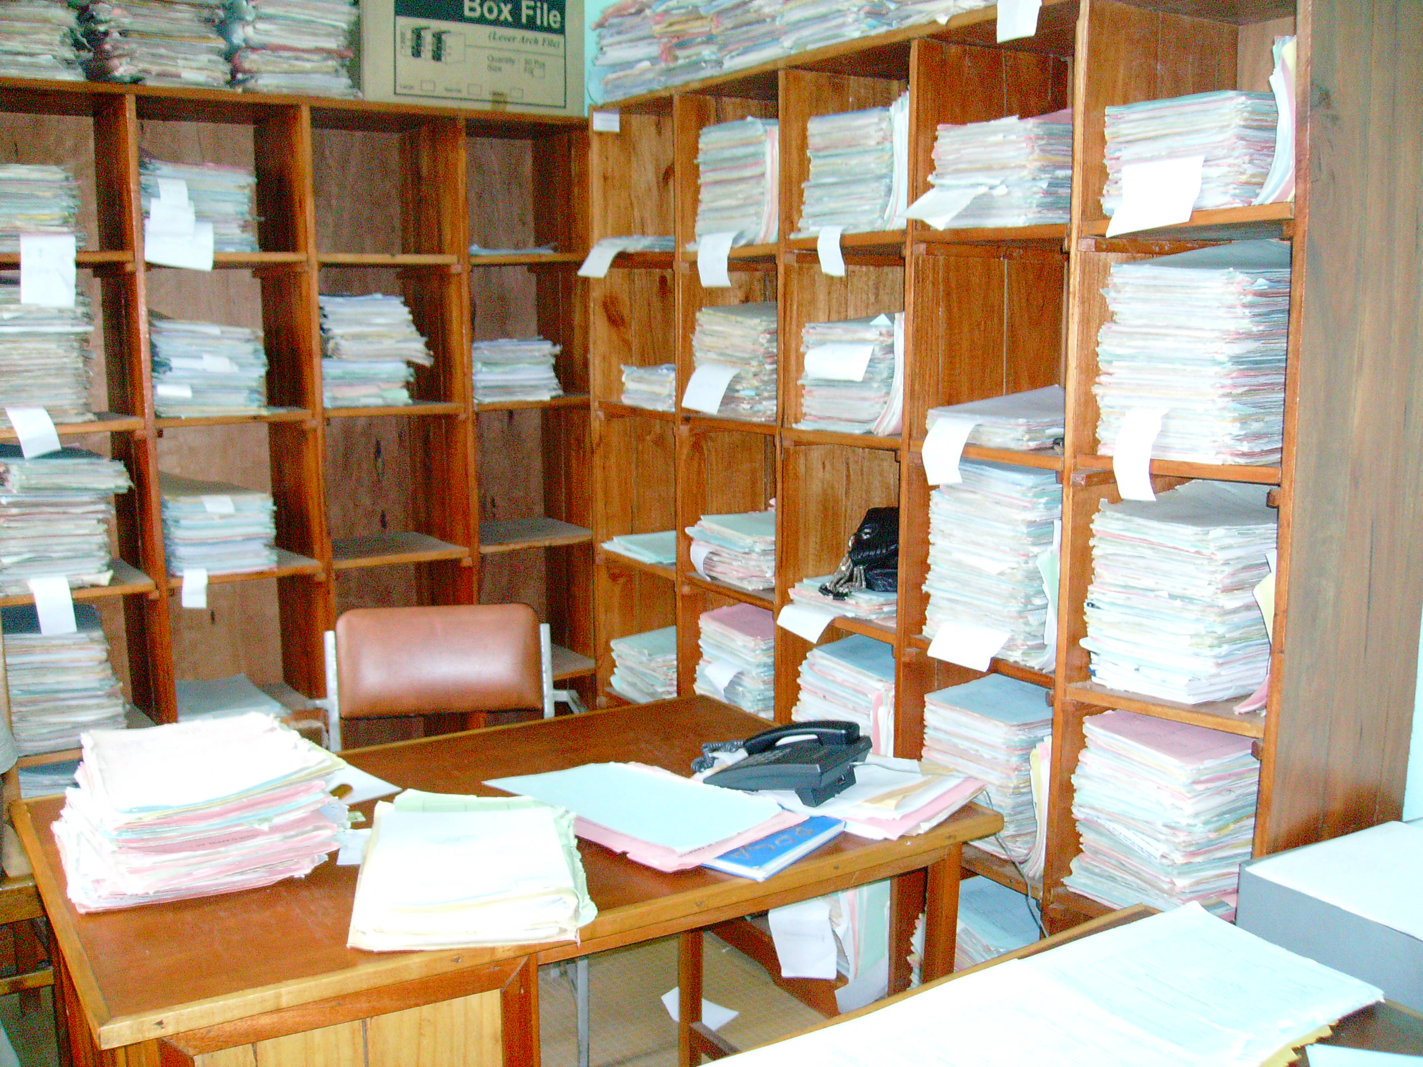

Active records of the Supreme Court (Clerk's Office)

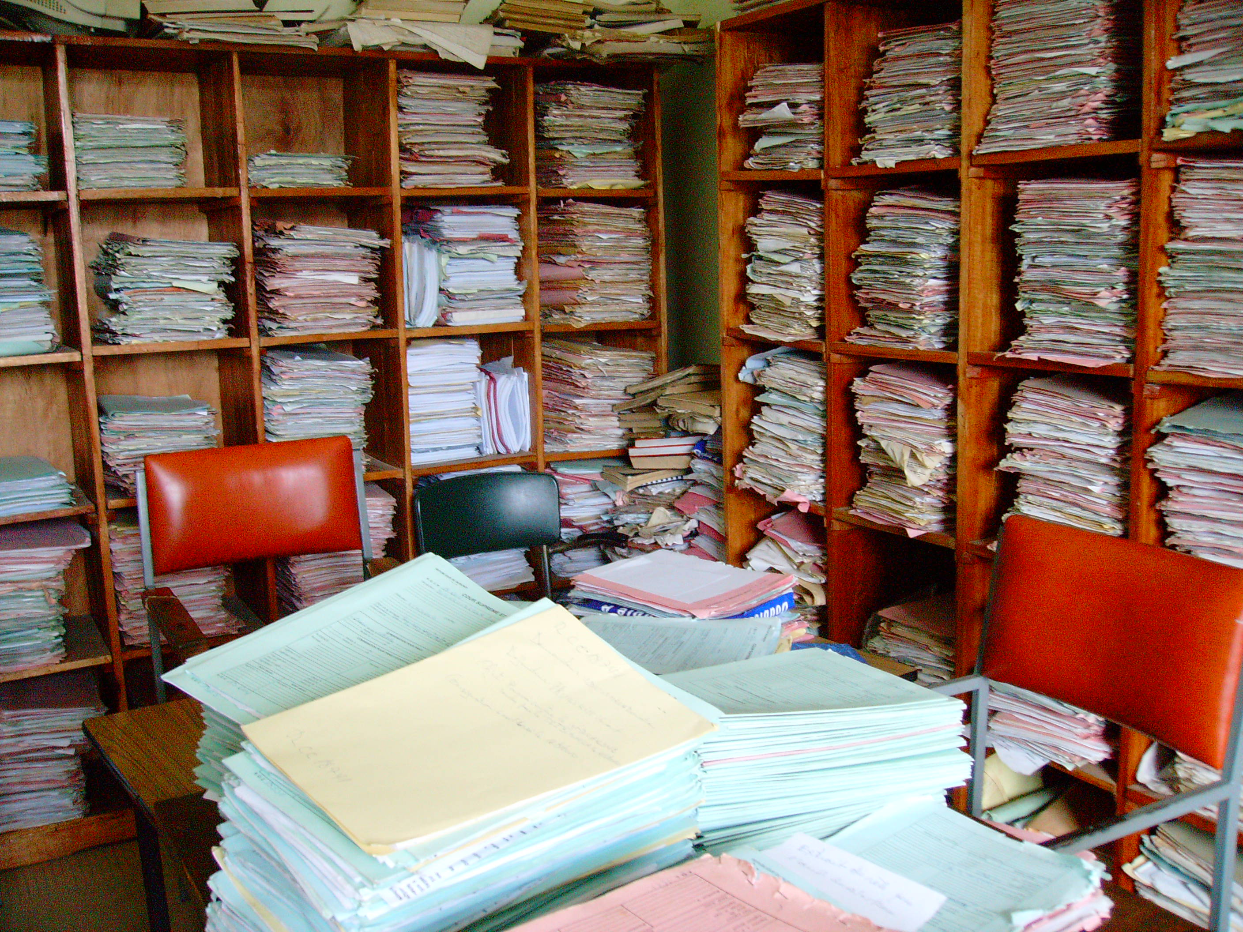

Active and Semi-Active Records of the Supreme Court (Clerk's Office)

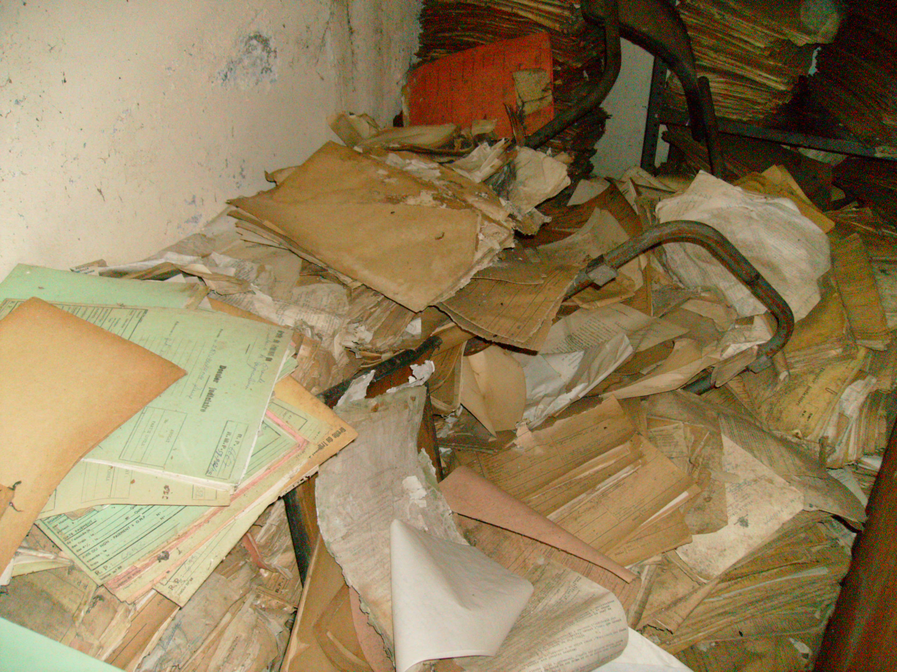
Archives damaged by the rain that passed through aeration holes (Basement Supreme Court Building)

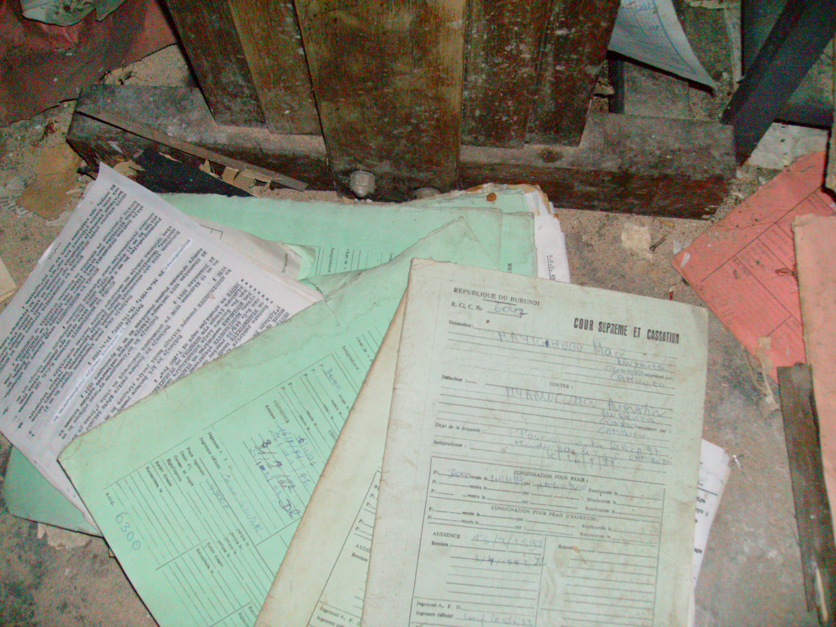
Archives (Basement Supreme Court Building)

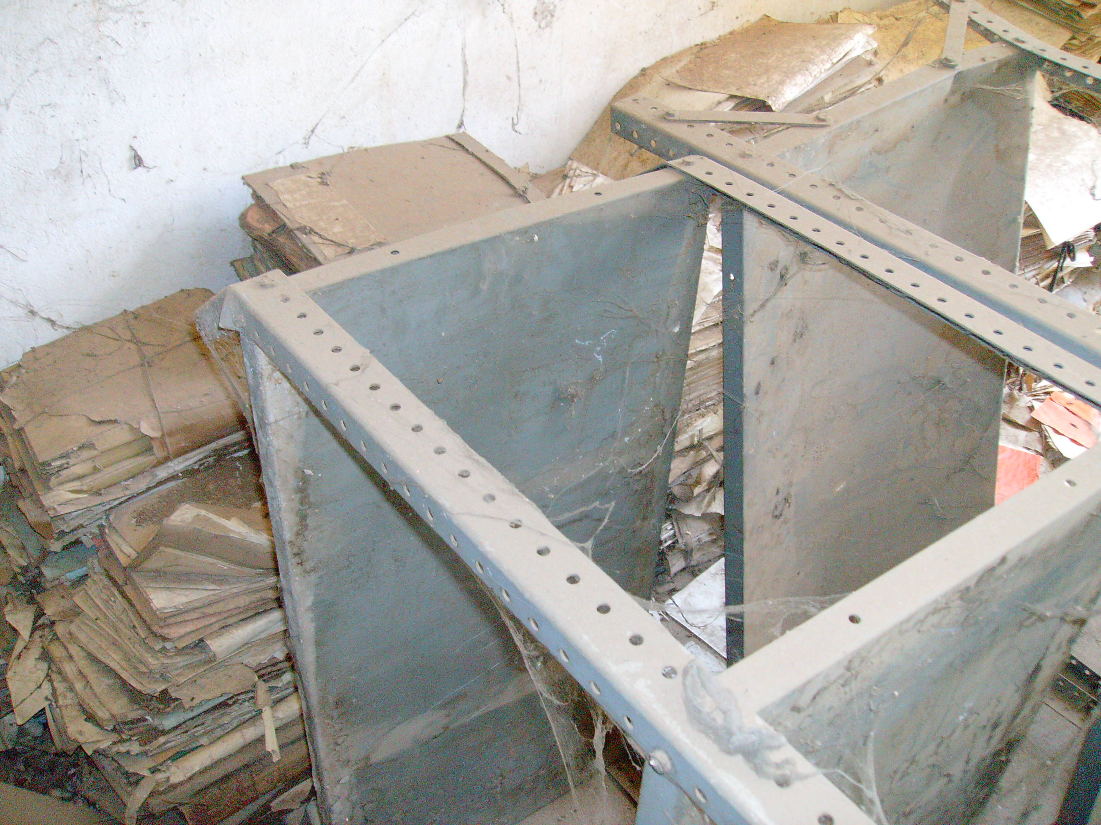
Archives (Basement Supreme Court Building)

Records Management Integration with Case Management Systems

Although the Supreme Court, in co-ordination with the European Union, is beginning to examine workflow processes in order to automate court functions, this is being done without input from the court registrar or clerks or from the National Archives staff. The Supreme Court of Burundi still manually processes and files active and semi-active records; there is no electronic case management system in place. The Supreme Court, however, is endeavoring to address some of its record-keeping issues by hiring a consultant to begin cataloging and classifying court case files.

Conclusion

The Supreme Court of Burundi faces many challenges in the areas of ICT/ e-Government and records management, which not only affect the operations of the Supreme Court citizens’ ability to assert and protect their rights. Presently, aside from the website planning and design project, there are no other planned ICT or e-Government projects in the Judiciary. The EU is analysing court processes and functions to ascertain how best to automate processes and enable greater workflow efficiencies. However, this project has not yet resulted in any tangible ICT or e-Government recommendations or outputs. Moreover, the Government of Burundi has cut ICT funding, and as a consequence ICT/ e-Government planning and implementation in MDAs and at the Supreme Court has stalled. The Supreme Court has therefore relied heavily on external/ international agencies such as the EU, BTC and RCN to build the necessary ICT/ e-Government capacity and infrastructure.

The Supreme Court has no records management programme. The lack of institutional records management policies and procedures has meant that records are poorly managed, making them difficult to retrieve and easily lost. Moreover, the absence of a comprehensive classification scheme has meant that records are disorganised, complicating service delivery and the effective operation of the Court. There are also a number of infrastructural issues that frustrate the proper management of records, such as the lack of space and resources for case file management. Once files are closed and placed in the 'archives' they are neglected and become difficult to retrieve; a number have been removed without authorisation.

The current state of ICT and records management programmes in the Supreme Court has serious implications for judicial proceedings and citizens’ rights. Lack of effective records management processes has meant that information, particularly about Supreme Court rulings, is not properly disseminated to lower courts. Some lower courts have therefore based their rulings on outdated or over-ruled judgments, which has impacted citizens and their ability to protect and defend their rights. Poorly managed and lost files have prevented individuals from accessing their court files and challenging previous convictions or rulings.

The misplacement and loss of files also curtails the Supreme Court's ability to effectively and efficiently manage its operations and be accountable for its rulings, which, in turn, affects the ability of citizens to trust the impartiality and fairness of the court. The absence of record-keeping controls will also impact the efficiency and efficacy of any future ICT systems implementation. Pre-existing record-keeping problems are transferred and then propagate in the electronic domain, affecting not only the integrity of court functions and processes but the very operations of ICT systems, which are meant to facilitate information retrieval in the courts.

