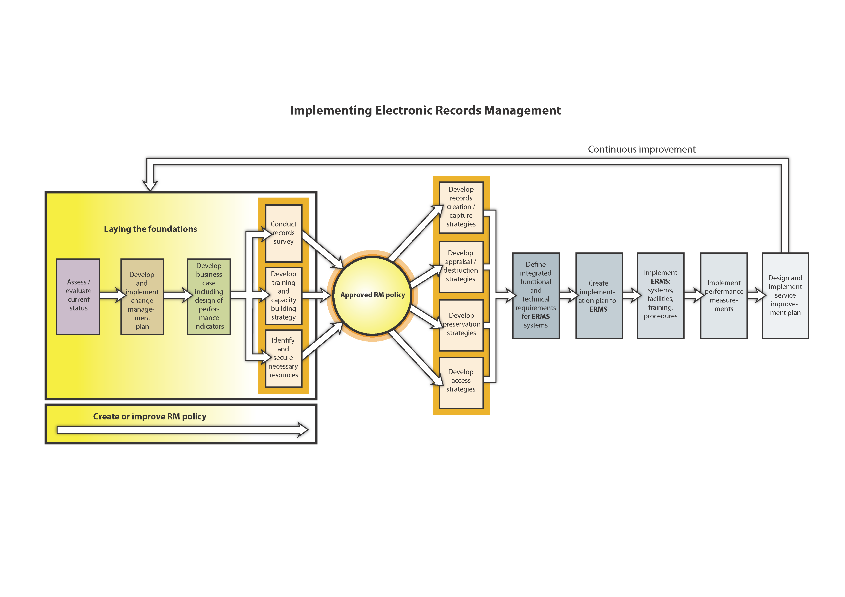
Implementing Electronic Records Management
Route Map developed by International Records Management Trust © 2009

