Designing a Records Management Improvement Programme

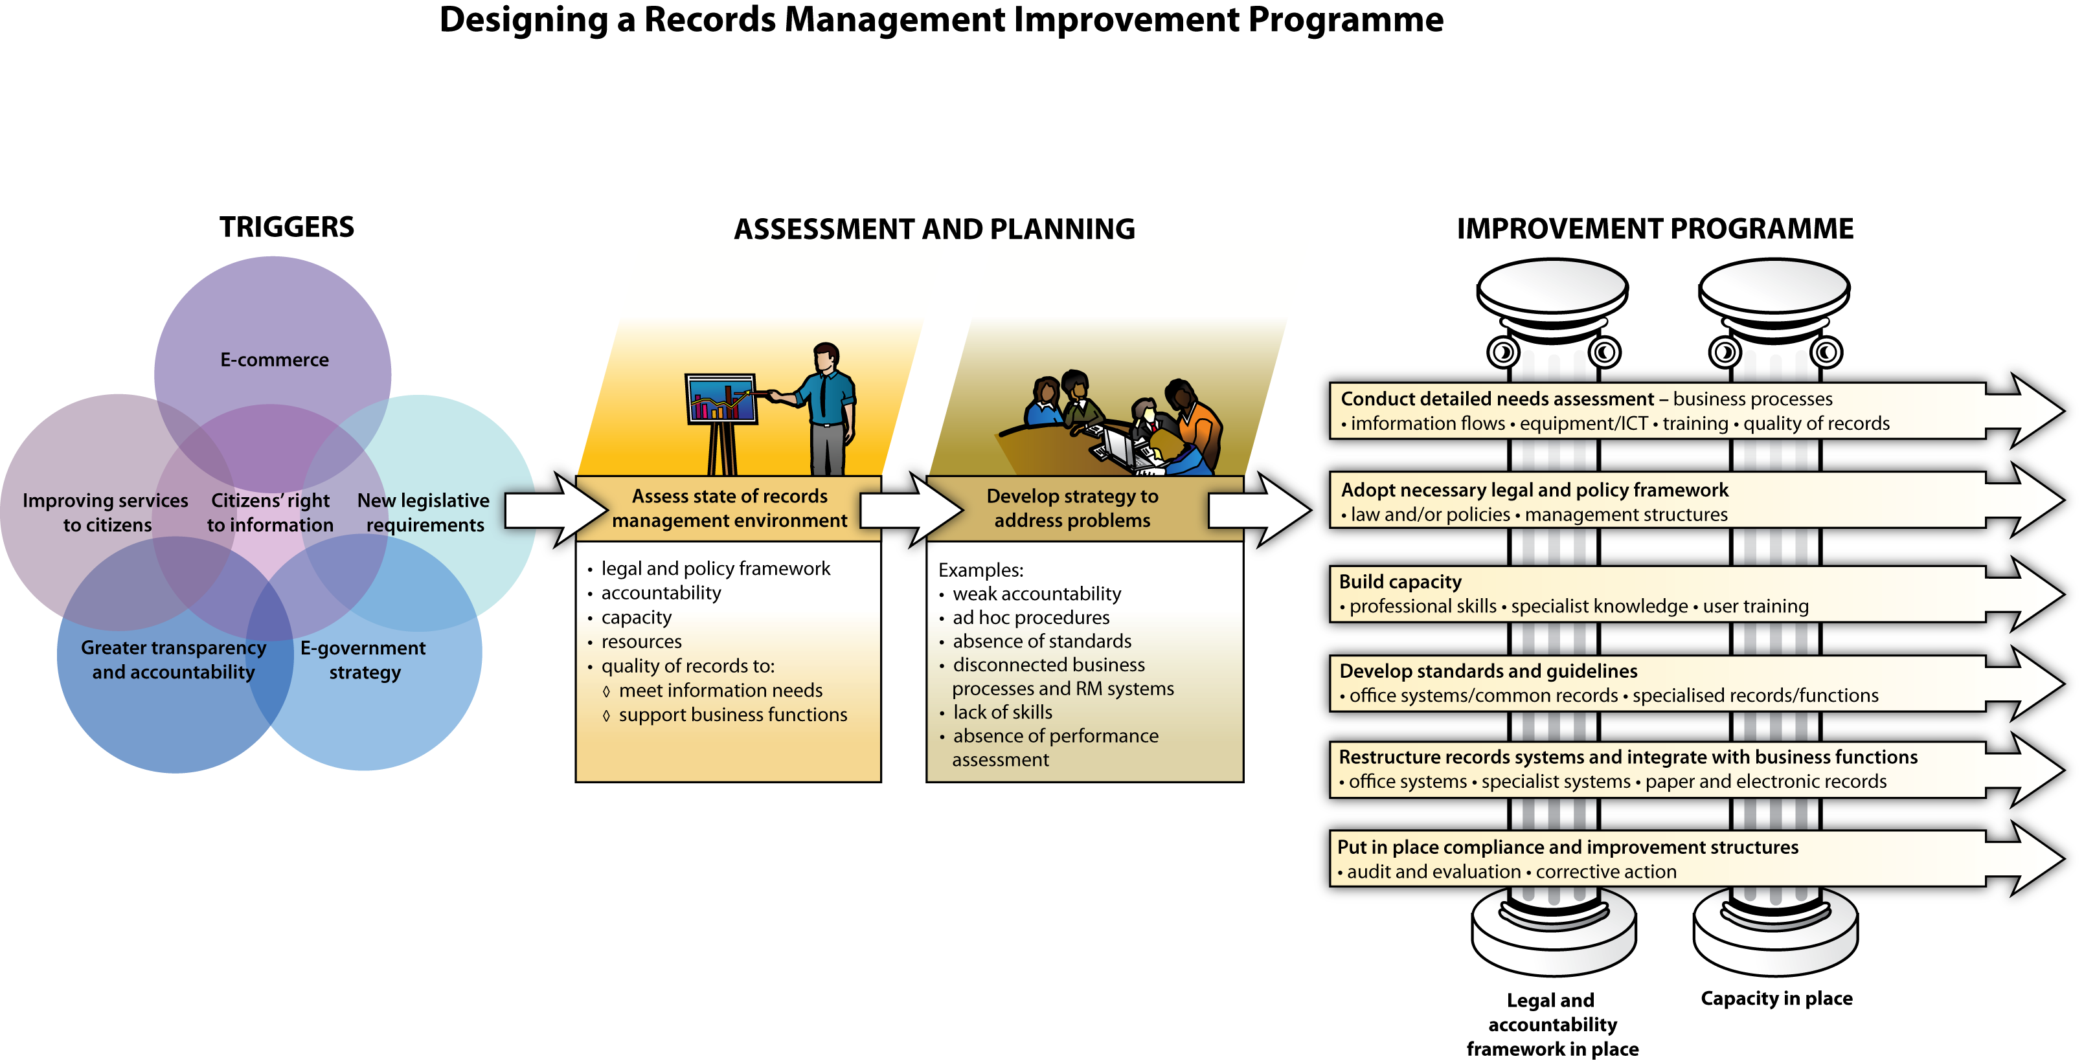
Route Map developed by International Records Management Trust © 2009

